


advancing embedded software

WebC



Features

- Written in Portable ‘C’ and ‘C ++’

- Runs Standalone

- Small Footprint

- Callback Mechanism for GUI Events Processing

- Dynamic User Interface

- Portable Graphics Layer
• Comprehensive Documentation



applications

• Set Top Devices
• Portable devices connecting to a central server
• Data collection devices
• Information kiosks
• Point-of-sale terminals
• Voice over IP Phones
• Handheld diagnostic tools
• On-screen display menus

Embedded Web Browser and GUI Development Kit

EBS’s WebC Embedded Web Browser and GUI Development Kit is a powerful tool for developing embedded Graphic User Interface applications. WebC is ideal for creating interactive screens and other GUI applications. WebC can also be used as a browser engine for Web-based internet applications.

Functionality highlights:

WebC provides embedded man machine interface technology using web based technologies. All major formats including png, mng, gif and jpg, Javascript and html are supported. User interface software can be written in Javascript and execute native 'C' code if necessary through a Javascript to 'C' trap door.

WebC includes a frame buffer driver and touch screen support for several system-on-a-chip solutions and requires no additional graphics package support .

Simple Development Environment:

WebC provides a dynamic html execution runtime environment for embedded devices that can also execute client side native machine code. If your user interface runs in a web browser, then it will run on your embedded platform with WebC. Content delivery is flexible. It can be via host to embedded sockets using HTTP over TCP/IP or through a file system, by direct compilation into the object code or via proprietary means.

Developed for GUI and Web enabled applications WebC’s support for CSS/2 and DHTML allows content developers to create user interfaces that can do more visually in a standards compliant manner.

The same software runs on a PC so the project engineer can prototype on a PC running Windows.

EBS’s WebC maintains a small footprint, making it ideal for embedded devices. WebC can run with or without an RTOS, Network stack, File system, or Graphics package.

Extreme Portability:

EBS WebC is portable to any OS, any CPU. EBS’s RTPlatform makes it simple to port WebC to new platforms by providing a clean interface to system functions. Browser-level event handling allows a greater level of integration between WebC and the system into which it is embedded.

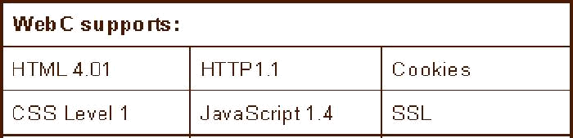
WebC’s runtime graphics driver binding allows developers to change graphics libraries without re-compiling the core browser code. A full GUI SDK is not necessary - WebC needs only graphics primitives and an output canvas to create high-quality rendered HTML.

Requirements:
Processor: Any 32 bit, 30+ mhz processor.
Compiler: Any ANSI compliant C++ compiler.
Footprint and Memory: 1MB RAM, 500K minimum footprint.

May 2009

ebsembeddedsoftware.com

EBS, Inc. • 39 Court Street • Groton, MA 01450 • Voice 978.448.9162

